**Temperature Mapping of Conductive Heat Transfer Through a Printed Circuit Board**

**By:**

**Tom Otero**

**Jeremy Lowman**

**Griffin Johnson**

**Tyler Benson**

**Parker Southwick**

**ME 411 Engineering Measurements and Instrumentation**

**03-18-2019**

# **Introductio**n

Printed circuit boards (PCB) are common in the field of modern electronics. Understanding the thermal behaviour of a PCB enables engineers to optimize heat management solutions. Specifically, this experiment aims to map the temperature gradient around a power resistor for a PCB of similar specifications to that used in Oregon’s first CubeSat, OreSat. This satellite will be deployed in low Earth orbit, which means the atmosphere will be too thin to permit convective cooling. Therefore, alternative methods must be used for managing the heat generated by the electrical components within OreSat.

Conduction, in terms of heat, is the process by which energy is transferred through a substance when there is a temperature difference. This relationship is defined by Fourier’s Law,

**

where q represents heat flux, k is the thermal conductance, and is the temperature gradient. Conduction is the primary mode of heat transfer in this experiment; however, convection will play a role.

Convection is the form of heat transfer in which heat flows from one place to another by the movement of fluids. Convection typically has two forms, forced and natural. Any form of convection where the fluid flow does not occur naturally is forced convection. To emulate the environment where the PCB will be operating, a chamber was used to eliminate forced convection. However, the enclosure used in this experiment did not support vacuum capabilities, so natural convections will still affect the system’s heat transfer. Natural convection is governed by a set of equations describing continuity, momentum, and energy. Respectively, these governing principles are described as follows,

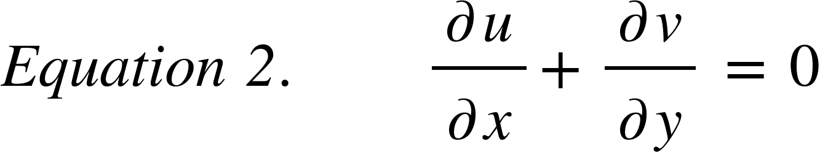

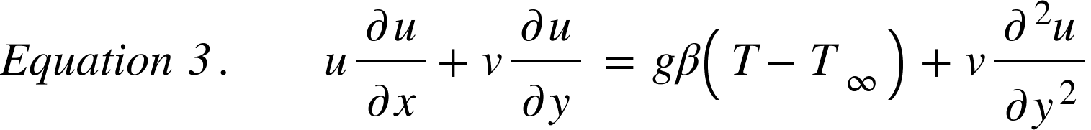

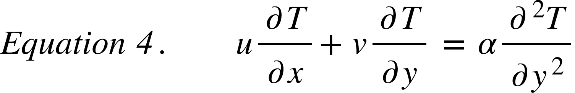

For more detail on natural convection, reference *Fundamentals of Heat and Mass Transfer* [1].

Thermal radiation is the last mode of heat transfer. Contrary to the previously mentioned forms of heat transfer, radiation does not require a medium to transfer energy. Radiation is the emission of energy as electromagnetic waves or as subatomic particles. Thermal radiation is a specific type of a radiation often called infrared because it operates within the infrared section of the electromagnetic spectrum. All matter at a nonzero temperature emits thermal radiation, and it is through this principle that the experiment will record the temperature gradient across the PCB under test.

**Methods and Apparatus**

A 10 power resistor rated for 50 W was installed on top of a 2-layer PCB. The power resistor was adhered to the surface of the PCB using thermal paste across its bottom surface, and placed in an area with the least amount of surface components. Installing the power resistor in an area with a low amount of surface components was done to avoid complicating calculations for natural convection and heat flux. The power resistor was placed in a simple series circuit with a Tektronix PS280 power supply. A small wooden enclosure, displayed in figure 1, was placed and taped down around the the PCB to reduce the effects of forced convection and outside radiation sources. A full assembly of the experiment is displayed in figure 2. An infrared camera was held in a fixture above the opening of the enclosure. The camera was used to map the temperature distribution across the circuit board as the power resistor was held at a steady state temperature and a constant voltage. As a control for the experiment, heat transfer data was collected from the PCB and power resistor with the system exposed to an open atmosphere and the infrared camera secured only by hand. The infrared camera was placed above the enclosure’s opening, and clamped in place. Two following measurements were taken with input voltages of 6 and 12 V were used for data collection. Steady state temperatures of the power resistor and conduction through the board were collected.

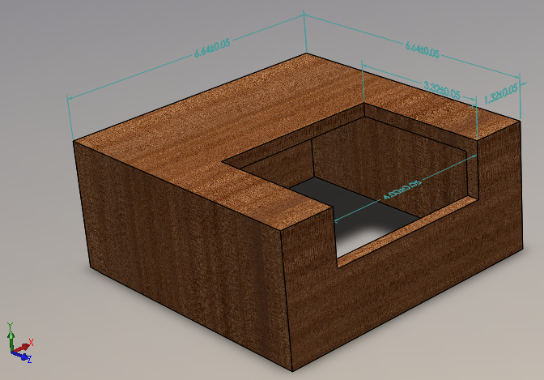**Figure 1.** SolidWorks model of the enclosure used for the experiment. Units in centimeters.

**Figure 2.** FLIR camera and enclosure used in the experiment. Inside the enclosure is a resistor connected to two leads and attached to a printed circuit board. 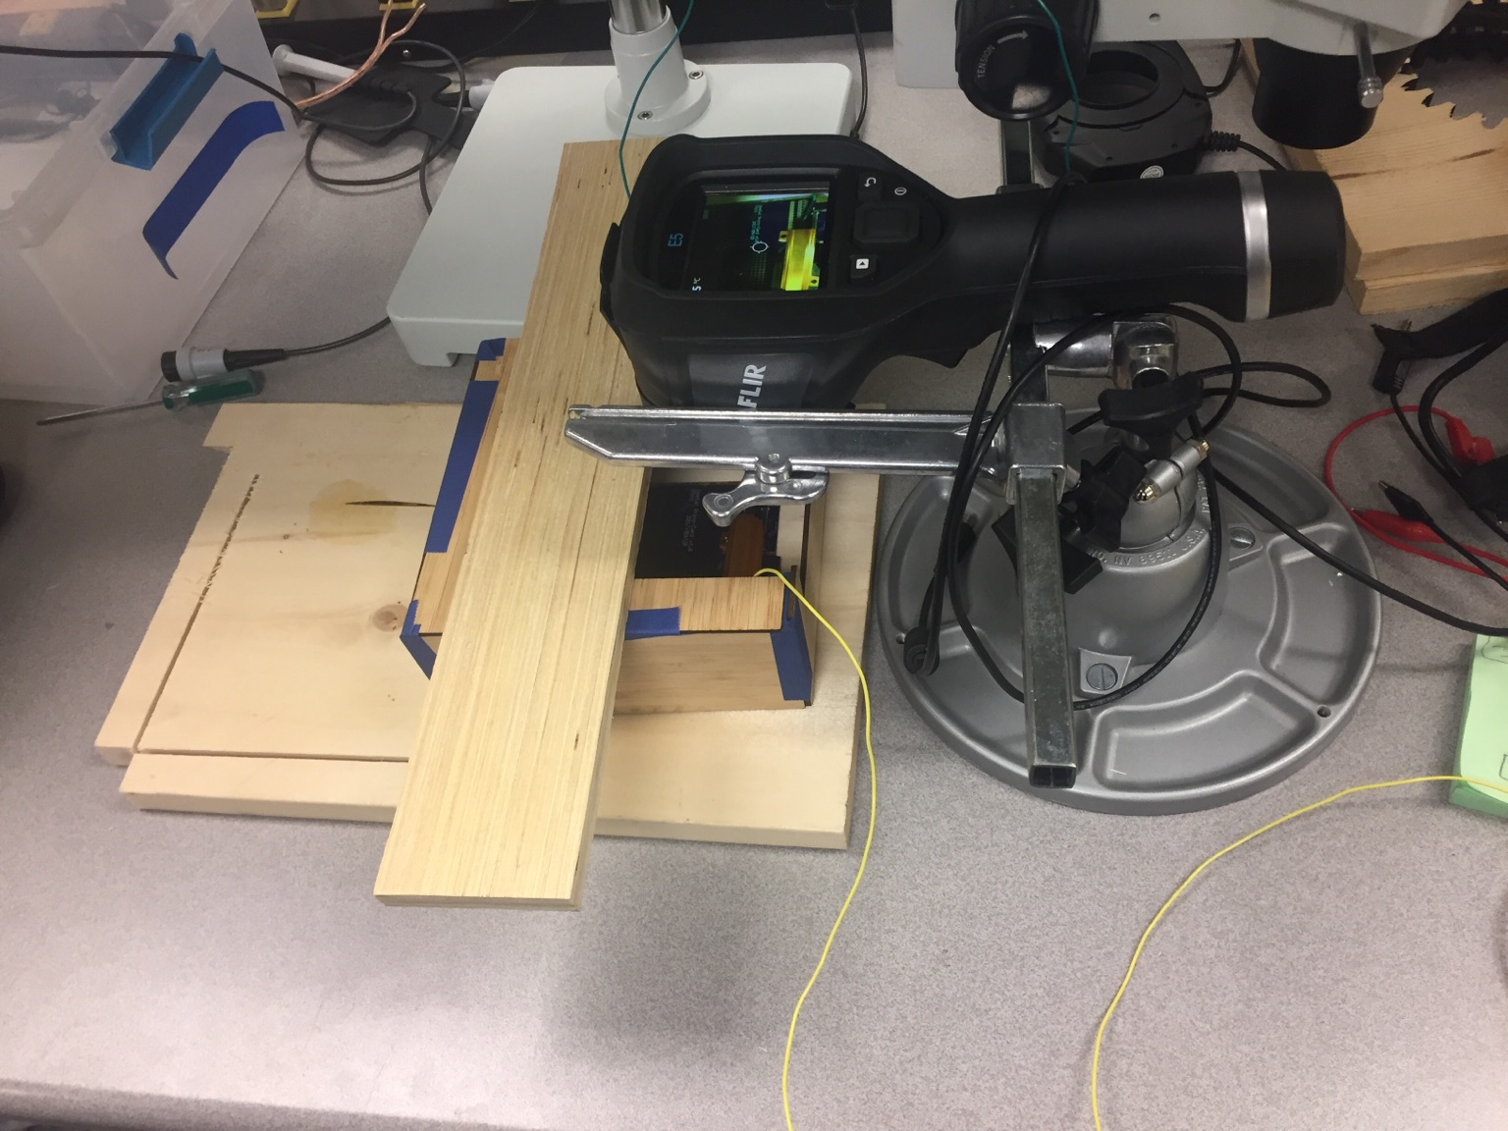

# Results

The 6 V trial had a steady state surface temperature of 341.6 K. This surface temperature yields a Rayleigh number of 6.87 E6, a Nusselt number of 27.7 and a Natural convection coefficient of 3.21 W/m2K. This was then used to calculate the total natural heat transfer which was found to be 0.186W. The natural heat convection was then used to determine the heat going from the resistor to the PCB by subtracting it from the total heat of 3.6 W. The heat going into the board was determined to be 3.4 W. With the heat going to the board calculated the conduction through the board be found using the FLIR camera. Figure 3 shows the thermal image of the 6 V trial and the area over which the temperature was recorded.

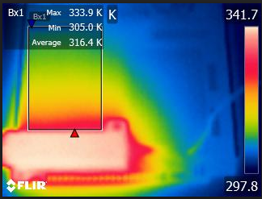

**Figure 3** Image taken by the FLIR thermal camera for the 6 V trial. This shows the heat gradient throughout the PCB going from a max temperature of 341.7 K to 298.8 K. The square is the area where the data was measured.

The data was then plotted as individual trials starting from the resistor ending at cold side on top. These were then plotted in figure 4. A linear fit was then added to calculate the conduction through the PCB. This was found to be an average of 10.5 W/mK.A 2nd trial was run at 12 V. Figure 5 displays the results from trial 2. At 12 V the average conduction coefficient was found to be 13.2 W/mK.

**Figure 4.** The plotted results of the 6 volt trial in the PCB. There is a negative slope which indicates the PCB is cooling the farther it is from the heat source. 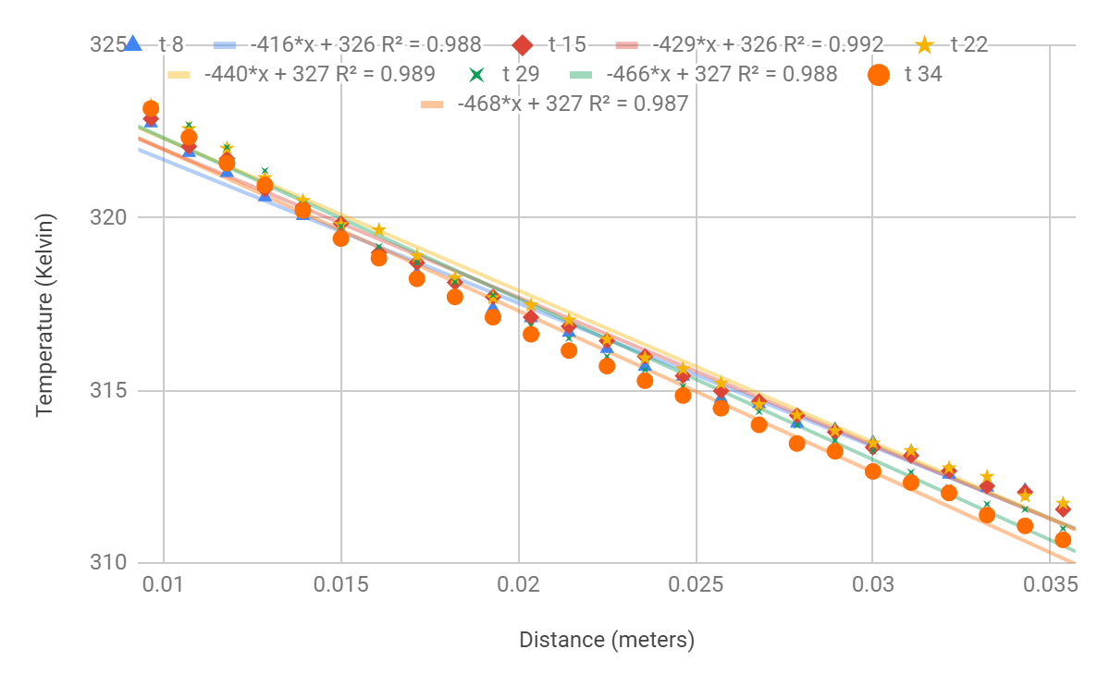

**Figure 5.** The plotted results of the 12 V trial in the PCB. It similar to the 6 V trial there is a heat gradient across the PCB that gets colder the farther from the heat source.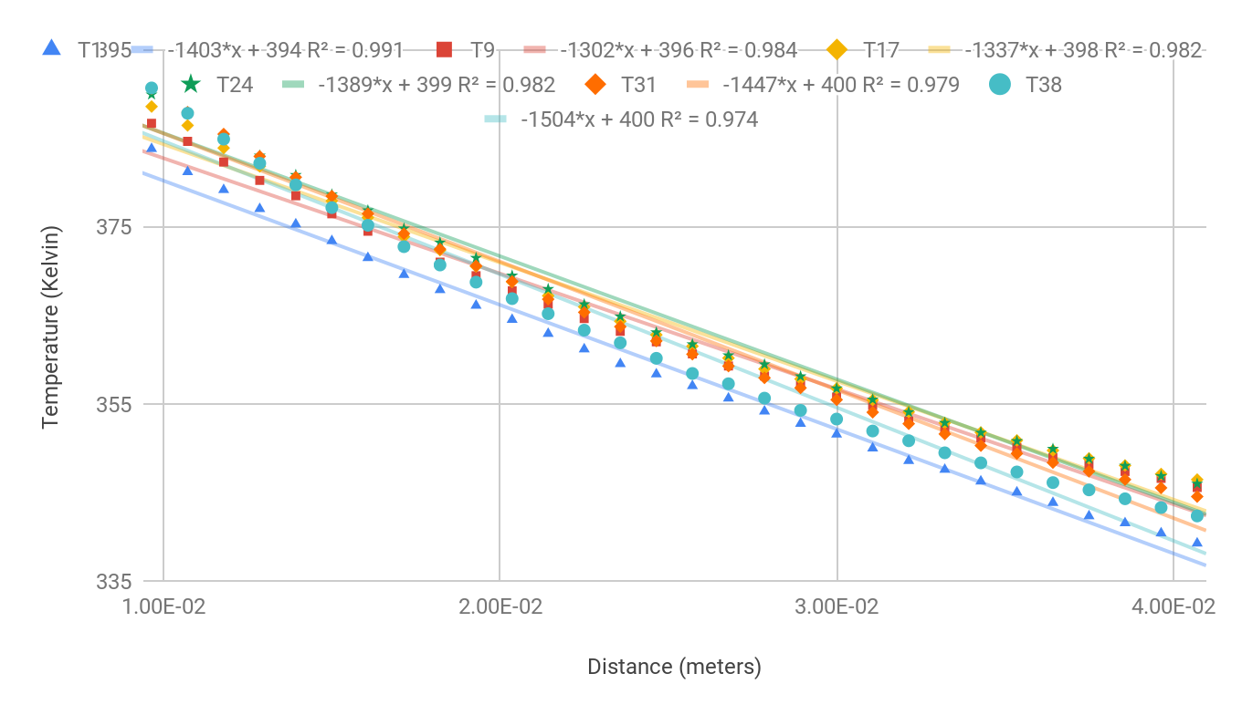

Additional trials for both cases were run using a line measurement instead of an area measurement, see figure A.1 through A.3 in the appendix. The average of every trial run was then taken to get a total average of 12.16 W/mK.

# Discussion

A standard 2-layer printed circuit board with total copper thickness of 0.70has an in-plane thermal conductivity of 17.4 W/mK assuming a uniform copper layer. [2] Considering that the surface which heat transfer was measured across was not uniform, which is seen in figure A.5, a value of 12.16 W/mK is reasonable.

Due to this experiment being performed in open atmosphere, there was a necessity to reduce the effects of forced convection. The enclosure in the experiment assisted in eliminating forced convection from adversely affecting our results. Additional error was reduced with the enclosure by isolating the test subject from the heat emitted by technicians observing the experiment. The heat conduction from the power resistor through the board was also affected via the thermal paste used.

Figures A.2 and A.4 depict linear trends when measuring temperature of the PCB as a function of distance. This linear relationship is defined by Fourier’s Law of Conduction outlined in equation 1. The slight deviations to linearity may be connected to the FLIR camera's programming which specifies perpendicularity for improved accuracy. Further, the area measurement shown in figure 3 produced greater linearity in results because it was taking a wider range of values which helped reduced the error.

Performing this experiment in a vacuum chamber would eliminate the need for an enclosure and accounting for convective heat transfer. Sources of error for this experiment include vibrating the infrared camera and the presence of convection.

# Conclusion

Mapping the temperature distribution from a resistor across a printed circuit board that will be used in the OreSat nanosatellite has allowed for a greater understanding of it’s thermal behavior. Further simulations will now be conducted with greater accuracy. By using Fourier’s law in conjunction with the governing principles of convective heat transfer, a value for an effective rate of thermal conductivity has been determined. According to our data , an effective thermal conductivity of the circuit boards to be used in OreSat is estimated at 12.160.67 W/mK with 95% confidence. This shows that the circuit boards to be used are not

particularly effective at conducting heat away from heat sources. Given that OreSat will be operating in a vacuum where convection will not be a factor, radiation will play a considerable part in the heat transfer from internal components.

Understanding the thermal behaviour of the PCBs used in the OreSat satellite enables greater accuracy and complexity for future thermal analysis.

# 

# References

[1] Bergman, T. L., and Adrienne Lavine. *Fundamentals of Heat and Mass Transfer*. Hoboken, NJ: John Wiley & Sons, 2017.

[2] Electronic Cooling Editors. *Conduction Heat Transfer in a Printed Circuit Board*. Electronics Cooling. May 1,1998 Accessed: March, 17, 2019

# 

# Appendix A

Appendix A contains data used to calculate the conduction coefficient through the PCB.

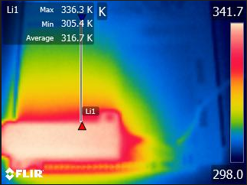

**Figure A.1.** Thermal image of the PCB running at 6 V with the Li1 line being where the data sample was collected.

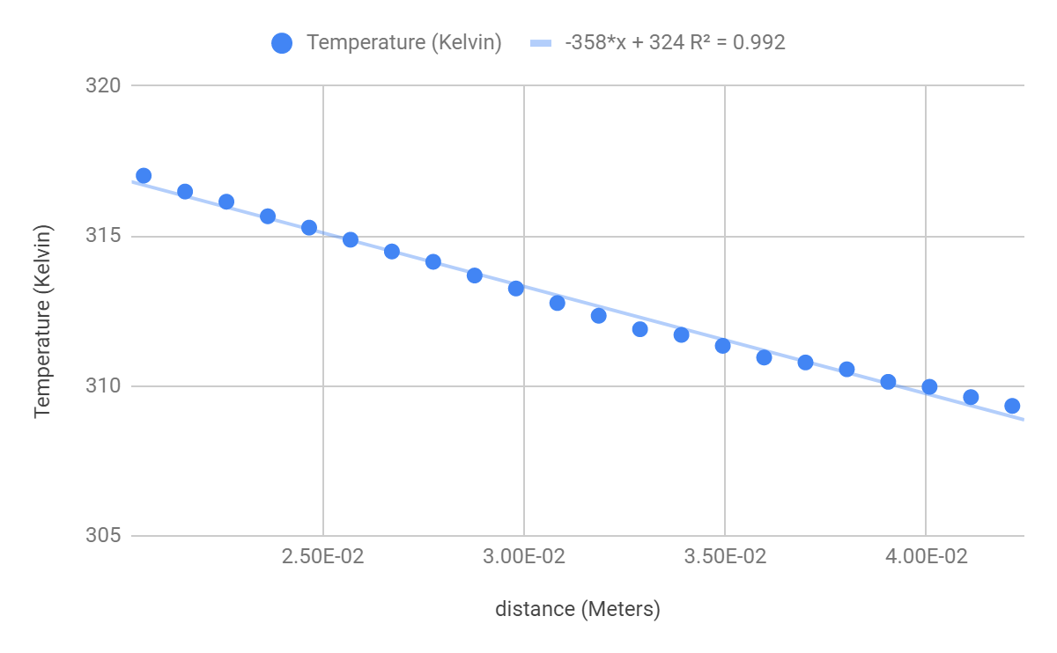

**Figure A.2.** The plotted results of the 6 V trial for Li1 in the PCB. The linear fit resulted in a slope of -358 K/m.

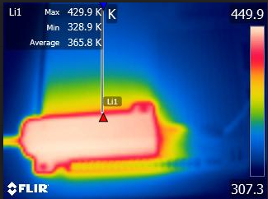

**Figure A.3.** Thermal image of the PCB running at 12 V with the Li1 line being where the data sample was collected.

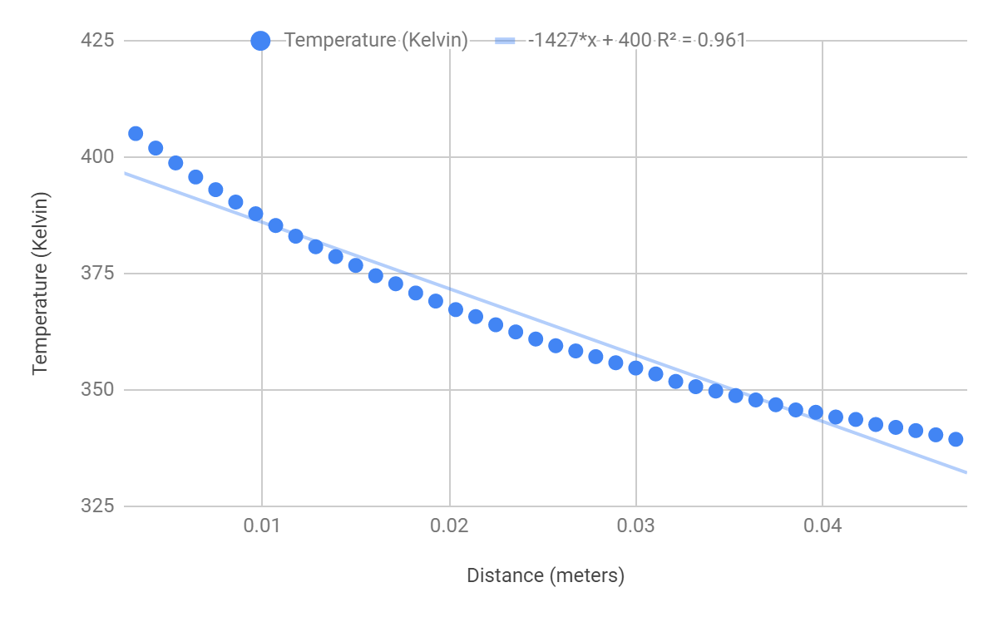

**Figure A.4.** Data from the Li1 12 V trial. A linear fit was applied to match the linearity described in Fourier’s Law of Conduction. The temperature gradient based on linear fit is -1427 K/m. .

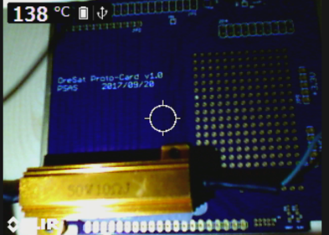

**Figure A.5.** Digital picture taken by the FLIR camera while it was heating up. This shows that the PCB that was being measured was not uniform, which could have introduce error into the data collected.

**Appendix B**

**Appendix B contains sample raw data collected by the FLIR camera.**

**Table B.1.** Sample of the 6 volt trial measuring temperature in Kelvin over the area of the circuit board

|  |  |  |  |  |  |
| --- | --- | --- | --- | --- | --- |
| t 1 | t 2 | t 3 | t 4 | t 5 | t 6 |
| 305.975 | 304.959 | 305.752 | 305.488 | 305.554 | 305.988 |
| 306.317 | 305.567 | 306.172 | 306.356 | 306.146 | 306.225 |
| 307.218 | 306.866 | 307.893 | 307.374 | 308.009 | 307.957 |
| 307.931 | 307.957 | 308.512 | 308.769 | 308.911 | 308.821 |
| 308.332 | 308.615 | 308.821 | 309.077 | 309.077 | 309.142 |
| 308.538 | 308.769 | 309.257 | 309.346 | 309.193 | 309.295 |
| 308.744 | 309.103 | 309.27 | 309.717 | 309.372 | 309.691 |
| 309.09 | 309.449 | 309.691 | 309.564 | 309.882 | 309.768 |
| 309.334 | 309.666 | 309.793 | 310.061 | 309.997 | 309.882 |
| 309.64 | 310.01 | 310.048 | 309.997 | 310.289 | 310.251 |
| 309.831 | 310.111 | 310.15 | 310.391 | 310.619 | 310.568 |
| 310.15 | 310.492 | 310.619 | 310.733 | 310.973 | 310.847 |
| 310.454 | 310.733 | 310.821 | 310.935 | 311.036 | 311.036 |
| 310.859 | 310.998 | 311.074 | 311.225 | 311.439 | 311.477 |
| 310.998 | 311.351 | 311.565 | 311.527 | 311.577 | 311.891 |
| 311.313 | 311.577 | 311.766 | 311.966 | 311.891 | 311.941 |
| 311.703 | 312.004 | 312.129 | 312.191 | 312.366 | 312.454 |
| 312.341 | 312.279 | 312.254 | 312.603 | 312.616 | 312.628 |
| 312.678 | 312.628 | 312.778 | 312.765 | 313.175 | 312.964 |
| 312.902 | 313.039 | 313.262 | 313.349 | 313.535 | 313.436 |
| 313.312 | 313.51 | 313.473 | 313.646 | 313.856 | 313.918 |
| 313.51 | 313.733 | 314.016 | 314.287 | 314.127 | 314.201 |
| 314.066 | 314.226 | 314.533 | 314.459 | 314.484 | 314.668 |
| 314.398 | 314.693 | 314.643 | 314.913 | 315.121 | 315.072 |
| 314.766 | 314.889 | 315.072 | 315.109 | 315.316 | 315.243 |
| 315.414 | 315.377 | 315.377 | 315.609 | 315.536 | 315.609 |
| 315.402 | 315.864 | 315.889 | 316.01 | 316.095 | 316.144 |
| 316.083 | 316.277 | 316.434 | 316.495 | 316.483 | 316.604 |
| 316.579 | 316.712 | 316.724 | 317.074 | 317.038 | 317.026 |
| 317.086 | 317.146 | 317.399 | 317.315 | 317.471 | 317.399 |
| 317.387 | 317.723 | 317.842 | 317.89 | 317.962 | 318.046 |
| 318.153 | 318.285 | 318.428 | 318.571 | 318.606 | 318.296 |
| 318.773 | 318.773 | 318.904 | 318.868 | 319.022 | 318.915 |